k-means clustering report

Taehoon Kwon

1. K = 3



1. K = 4



1. K = 5



1. K = 6



1. K = 7



1. K = 8



1. K = 9



1. K = 10



1. Best choice of K : 4

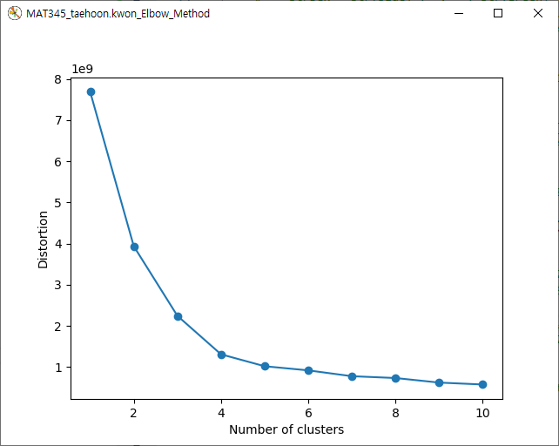

If K=10, it has the least distortion(error), which means it is the closest image comparing to the original image. However, we cannot say it is the optimal K. According to the ‘Elbow Method’, the optimal K could be chosen based on identifying the value of K where the difference in slope is the largest. In other words, there is only a slight change from K=5 but no major change.

Therefore, K=4 is the best case.